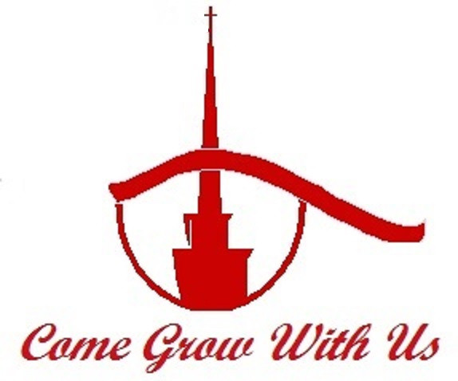

MT. PROSPECT BAPTIST CHURCH
Dr. James E. Potts, Pastor

Added Member Information Packet
Age 6-12 - Children

Welcome!

Making the commitment to be “part of the family” is just the first step in a mutually beneficial experience. I hope you have seen a genuine love for the Lord as you have been attending our services. We want to be a church that honors God and meets the needs of His people.

As you begin this new journey with us, we welcome you into our initial phase of the membership Orientation, which is mandatory for every new member. This New Member Information Packet will serve as a refresher for some and for others will contain new and vital information to assist you in growing in your Christian faith. Developed with both the young and older in mind, this packet gives the youth a firm foundation on which to grow while teenagers and adults are provided the building blocks for life in Christ. As an anchor for your walk as a member of Mt. Prospect Baptist Church, this New Member Information Packet gives the key biblical truths for all believers as well as information on what our church is all about.

In the next seven days, we are asking you to:

- Youth (ages 6-12) → Discuss the “Belonging” overview with your parents or guardian.
- Teenagers and Adults (13 and older) → Carefully review this entire New Member Information Packet and complete the exercise.
- Log on to www.mtprospectbaptist.org and…
  - Review information about Mt. Prospect
  - Check out the New Member information. (Once on the website, click the “For New Members” button under “Quick Links”)
- Register for your New Member Orientation by contacting the Church Office by phone or email. (New sessions begin the 4th Sunday of each month.)

Our desire is for each member, regardless of age, to be growing and serving in ministry. Membership is not just “another ritual” in the church. We do not want you to join Mt. Prospect and gradually disappear. Why the emphasis on “active” membership? We believe people grow when they are serving God. Serving God in the church is a rewarding experience. Personal and spiritual growth is enhanced when we serve each other “as unto the Lord.”

It is the desire of the Mt. Prospect Baptist Church that our new member’s orientation will be a time of challenging, comforting, cultivating, and Christian camaraderie, as we embark on this new journey together. My prayer is that as you join hands with the body of Christ at Mt. Prospect and allow the Word of God to speak to your heart that we will all be transformed into the image of Christ.

Your Pastor,

Dr. James E. Potts
Church Covenant

Having been led, as we believe, by the Spirit of God to receive the Lord Jesus Christ as our Savior; and on the profession of our faith, having been baptized in the name of the Father, and of the Son, and of the Holy Spirit, we do now in the presence of God, angels and this assembly, most solemnly and joyfully enter into covenant with one another, as one body in Christ.
We engage therefore, by the aid of the Holy Spirit, to walk together in Christian love; to strive for the advancement of this church in knowledge and holiness; to give it a place in our affections, prayers and services above every organization of human origin; to sustain it's worship, ordinances discipline and doctrine; to contribute cheerfully and regularly, as God has prospered us, towards it's expenses, of the support of a faithful and evangelical ministry among us, the relief of the poor and the spread of the Gospel throughout the world. In case of difference of opinion in the church, we will cheerfully recognize the right of the majority to govern.
We also engage to maintain family and secret devotion; to study diligently the word of God; to religiously educate our children; to seek the salvation of our kindred and acquaintance; to walk circumspectly in the world; to be kind to those in our employ, and faithful in the service we promise others; endeavoring in the purity of heart and good will towards all men to exemplify and commend our holy faith.
We further engage to watch over, to pray for, to exhort and stir up each other unto every good word and work; to guard each other's reputation, not needlessly exposing the infirmities of others; to participate in each other's joys, and with tender sympathy bear one another's burdens and sorrows; to cultivate Christian courtesy; to be slow to give or take offense, but always ready for reconciliation, being mindful of the rules of the Savior in the eighteenth chapter of Matthew, to secure it without delay; and through life, amid evil report, and good report, to seek to live to the glory of God, who hath called us out of darkness into his marvelous light.
When we remove from this place, we engage as soon as possible to unite with some other church where we can carry out the spirit of this covenant and the principles of God's Word.
Youth New Member Sessions
(ages 6-12)

It’s all about BELONGING…
- To your FAMILY
- To your CHURCH FAMILY
- To the FAMILY OF GOD

The Youth Sessions will cover the following topics:
- The Plan of Salvation
- What is Baptism and what does it mean
- What is Conviction and its role in our growth
- The Meaning of Church Membership
  - Conversion
  - Church Membership
  - Your New Life in Christ
  - Your Growth as a Christian
  - Your Bible and its use
  - Your Church and its Covenant
  - Your Church and its Beliefs
  - Your Church Working Together
  - Your Church Working with Others
  - Your Church and its History
  - Your Church and Your Home
  - Sharing Your Faith
  - Continuing Discipleship

Come and be ready to ENJOY learning your NEW LIFE in CHRIST!

